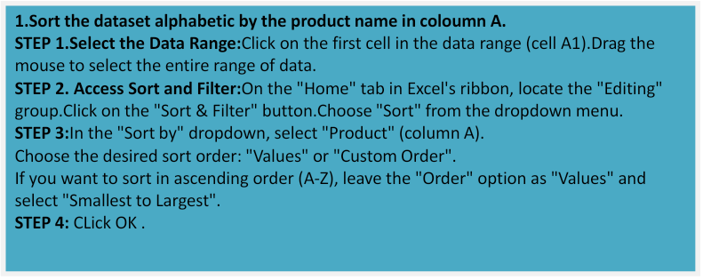

|  |  |  |  |
| --- | --- | --- | --- |
| **Product** | **Region** | **Date** | **Sale** |
| Product A | North | 01-01-2024 | 120 |
| Product A | East | 03-01-2024 | 200 |
| Product A | South | 06-01-2024 | 130 |
| Product B | South | 02-01-2024 | 150 |
| Product B | North | 05-01-2024 | 220 |
| Product B | East | 08-01-2024 | 80 |
| Product C | West | 04-01-2024 | 90 |
| Product C | North | 07-01-2024 | 300 |

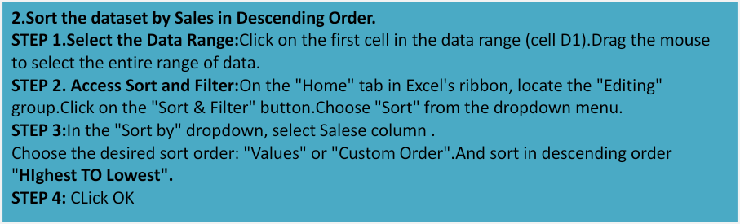

|  |  |  |  |
| --- | --- | --- | --- |
| **Product** | **Region** | **Date** | **Sale** |
| Product C | North | 07-01-2024 | 300 |
| Product B | North | 08-01-2024 | 220 |
| Product A | East | 09-01-2024 | 200 |
| Product B | South | 10-01-2024 | 150 |
| Product A | South | 11-01-2024 | 130 |
| Product A | North | 12-01-2024 | 120 |
| Product C | West | 13-01-2024 | 90 |
| Product B | East | 14-01-2024 | 80 |

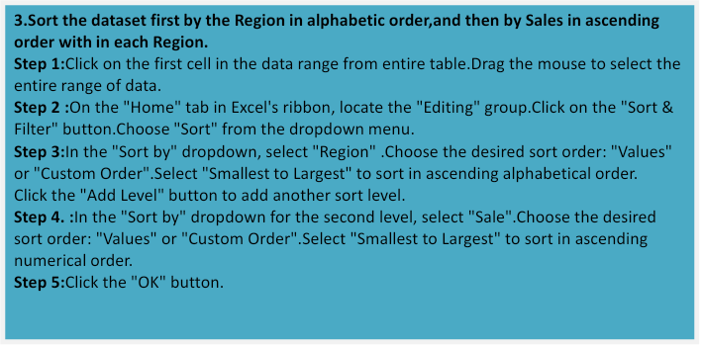

|  |  |  |  |
| --- | --- | --- | --- |
| **Product** | **Region** | **Date** | **Sale** |
| Product B | East | 08-01-2024 | 80 |
| Product A | East | 03-01-2024 | 200 |
| Product A | North | 01-01-2024 | 120 |
| Product B | North | 05-01-2024 | 220 |
| Product C | North | 07-01-2024 | 300 |
| Product A | South | 06-01-2024 | 130 |
| Product B | South | 02-01-2024 | 150 |
| Product C | West | 04-01-2024 | 90 |



|  |  |  |  |
| --- | --- | --- | --- |
| **Product** | **Region** | **Date** | **Sale** |
| Product A | North | 01-01-2024 | 120 |
| Product B | South | 02-01-2024 | 150 |
| Product A | East | 03-01-2024 | 200 |
| Product C | West | 04-01-2024 | 90 |
| Product B | North | 05-01-2024 | 220 |
| Product A | South | 06-01-2024 | 130 |
| Product C | North | 07-01-2024 | 300 |
| Product B | East | 08-01-2024 | 80 |

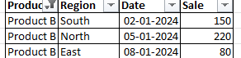

|  |  |  |  |
| --- | --- | --- | --- |
| **Product** | **Region** | **Date** | **Sale** |
| Product A | North | 01-01-2024 | 120 |
| Product B | South | 02-01-2024 | 150 |
| Product A | East | 03-01-2024 | 200 |
| Product C | West | 04-01-2024 | 90 |
| Product B | North | 05-01-2024 | 220 |
| Product A | South | 06-01-2024 | 130 |
| Product C | North | 07-01-2024 | 300 |
| Product B | East | 08-01-2024 | 80 |



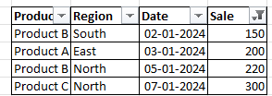



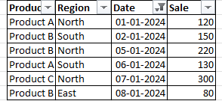

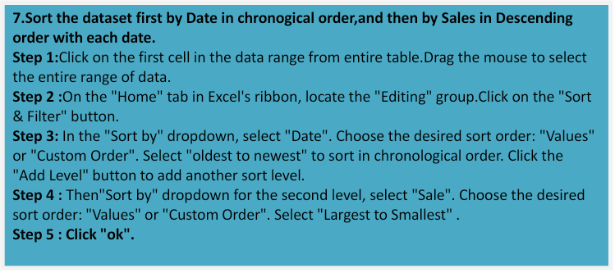

|  |  |  |  |
| --- | --- | --- | --- |
| **Product** | **Region** | **Date** | **Sale** |
| Product A | North | 01-01-2024 | 120 |
| Product B | South | 02-01-2024 | 150 |
| Product A | East | 03-01-2024 | 200 |
| Product C | West | 04-01-2024 | 90 |
| Product B | North | 05-01-2024 | 220 |
| Product A | South | 06-01-2024 | 130 |
| Product C | North | 07-01-2024 | 300 |
| Product B | East | 08-01-2024 | 80 |